ALLERGEN LISTING
- EGG

- MILK

- CRUSTACEANS

- MOLLUSCS

- FISH

- PEANUTS

- SESAME

- SOYA

- SULPHUR DIOXIDE

- NUTS

- CEREALS

- GLUTEN

- CELERY

- MUSTARD

THE KEEP
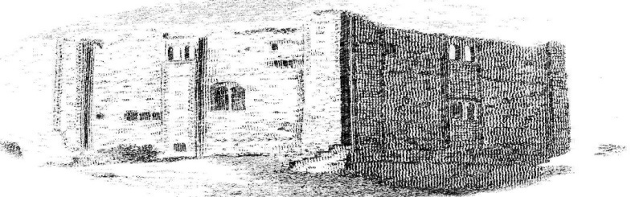
LIGHT BITES MENU
CHARCUTERIE or CHEESE BOARD
Stacked with Meats or Cheese
Salad Garnish & Bruschetta
@ £9.95 - Contains 1,2,9,11 &12
~
HOMEMADE SCOTCH EGG
With A Salad Garnish @ £4.50
Contains – 1,2,9,11 &12
Ask at the Bar for Cake Availability
The Keep, 29/30 Castle Street, Guildford, GU1 3UW
Tel: 01483 450600
E mail: Thekeepguildford@yahoo.co.uk
Web :www.thekeepguildford.com

THE KEEP’S
SUNDAY MENU

Served 2 – 5 pm
TRADITIONAL PLOUGHMAN’S LUNCH
Served with Mature Cheddar, Stilton & Brie
Celery, Apple, Chutney & Crusty Bread & Butter with a Salad Garnish
@ £10.95- Contains 1,2, 11, 12 & 13
~
HOMEMEMADE TADITIONAL ROAST
Served with All The Trimmings
@ £12.00 - Contains 1,2, 11, 12 & 13
~
THE KEEP’S LIGHT BITES MENU

